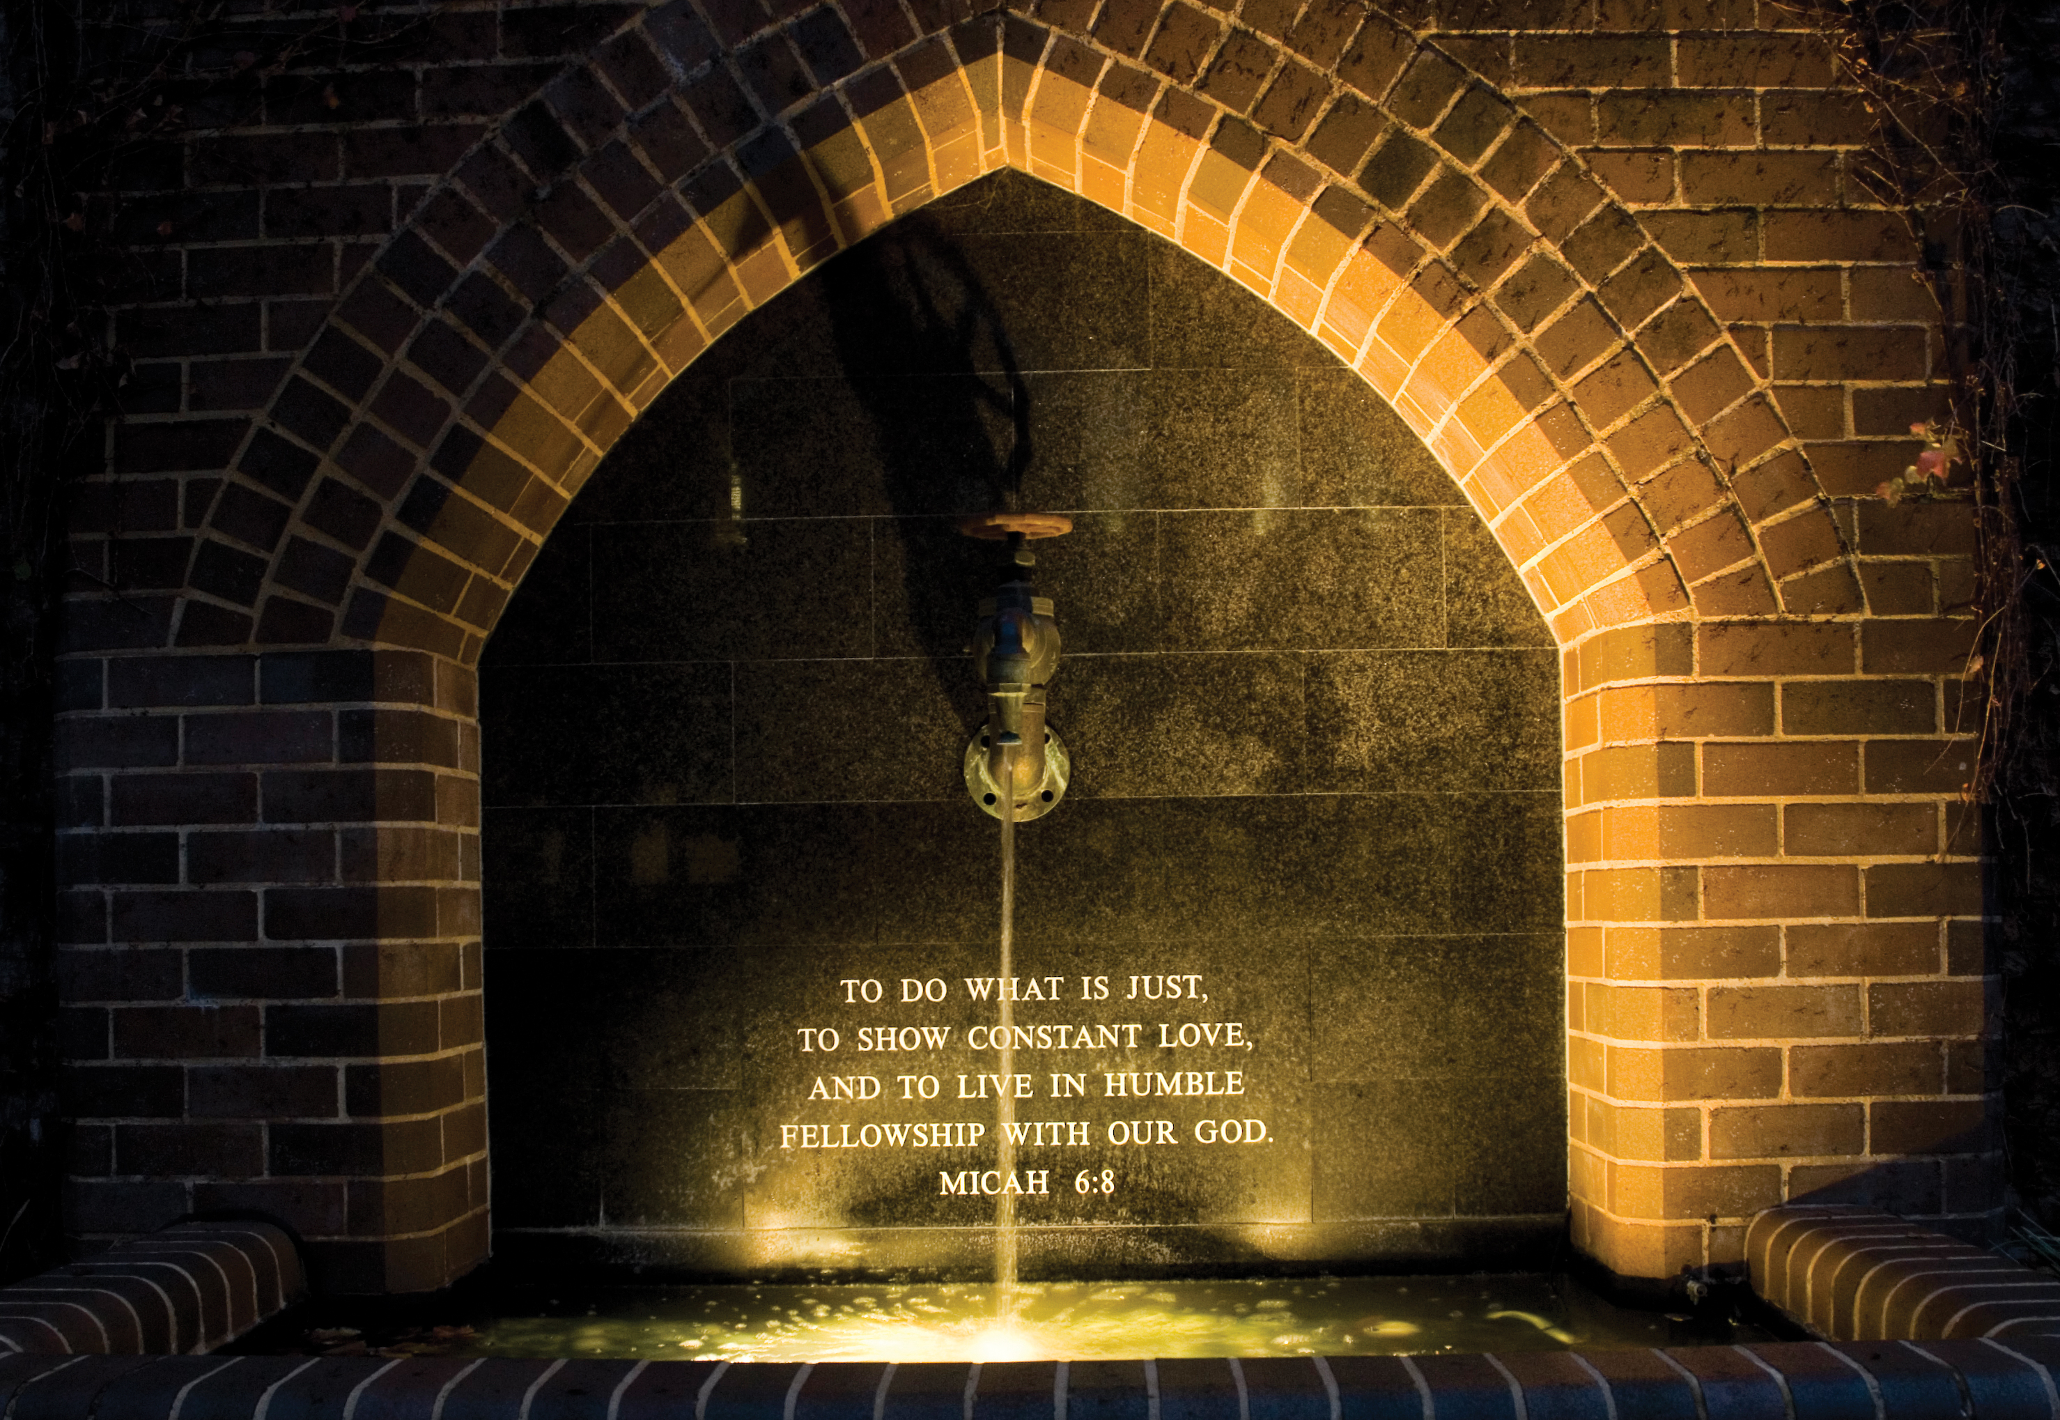

Event heading – Arial Bold 38pt

Day Date Month – Arial 30pt

Time – Arial 24pt
- Additional Information – Arial 16pt
- Additional Information – Arial 16pt

Venue: The University of Notre Dame Australia
Room (NDXX), Address – Arial 16pt

For further information 08 9433 0533 | future@nd.edu.au

