Accessing Open-Book Examinations throughTurnitin

- All examinations for the School of Education will be open-book. This means that you are able to access your lecture and tutorial notes, as well as textbooks and readings. The exams will be completed via Turnitin at the same dates and times that have been released on the mid-semester timetable.
- If you currently have a Learning Adjustment Plan (LAP), please provide a copy to your course coordinator prior to exam week.
- To access where the exam will be released and submitted, click in the Assessment tab of the Blackboard (left hand menu).
- There will be a folder called Examination as per the image below. This folder will be available in Week 9. Click into the folder.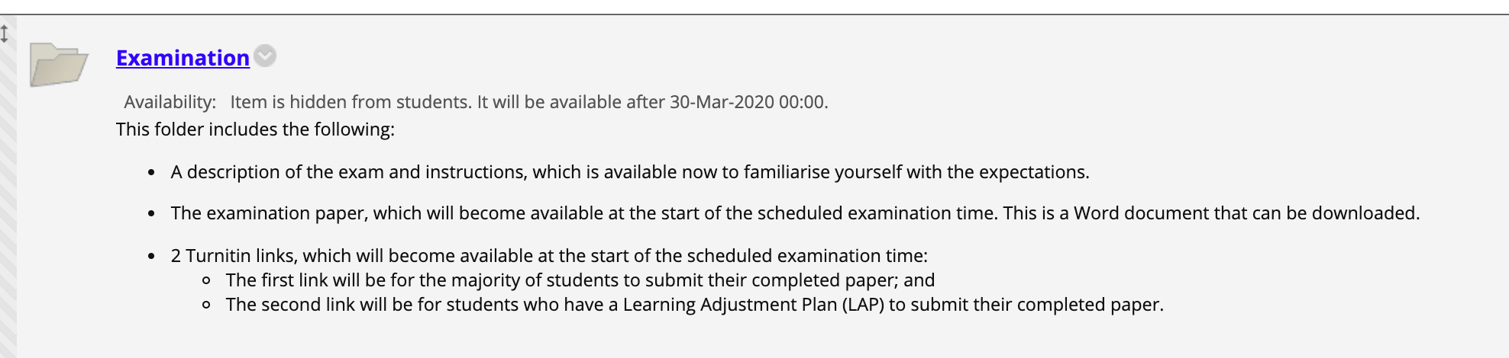
- In the folder will be an item called EDUCXXX Exam Description and Instructions. This item provides a description of the exam and instructions, so that you are familiar with the expectations of the exam.
- A second item called Examination Paper will be made available at the time of your scheduled exam. The exam will be here as a Word document that can be downloaded at the start of the exam. An exam is provided below of what this may look like:
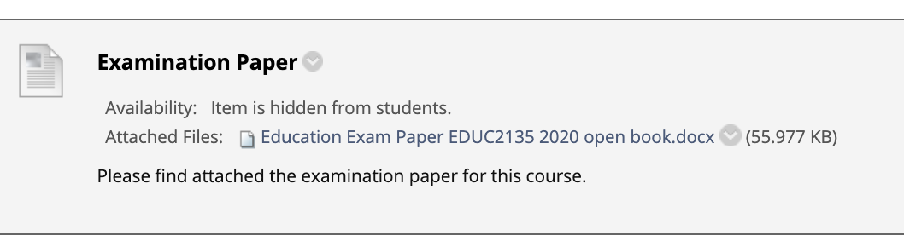
- Two Turnitin links will be visible. These links are where you will submit your exam. The exam must be submitted within the time frame. For example, if your exam begins at 9am and you have 2 hours and 10 minutes to complete it, you will need to upload your document by 11:10am. If you have a Learning Adjustment Plan, please upload your document via the LAP link. All other students are to select the first link. A picture of this is shown below:
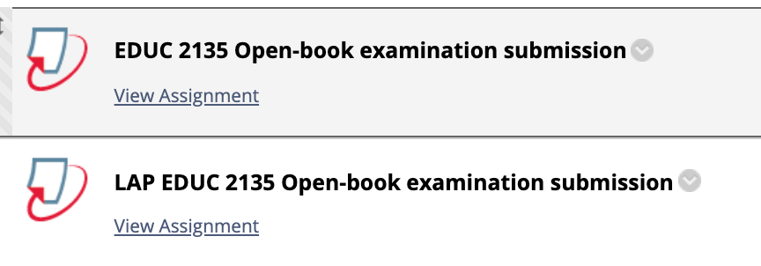
- It is important to manage your own time during the examination as no time warnings are provided.

- If you have any issues with submission, please email the document to your course coordinator within the exam time frame. Please continue attempting to upload it to Turnitin. Late submissions without communication with your course coordinator will incur a penalty of 1% per minute.

