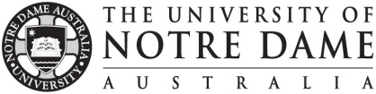
Application Coversheet
Vice Chancellor’s Awards - Promoting Excellence in Learning and Teaching (PELT)
AWARD TYPE: Initiatives that Enhance Student Learning

- Name of Applicant/s (add extra rows for teams up to 10 staff)

- Nomination Category (choose one)

  - Approaches to teaching and/or the support of learning that influence, motivate and inspire students to learn
- Development of curricula, resources or services that reflect a command of the field
- Evaluation practices that bring about improvements in teaching and learning
  - Innovation, leadership or scholarship that has influenced and enhanced learning and teaching and/or student

- Title of the Initiative (in 25 words or less)

For....

- Application Checklist:
- Coversheet
- Written statement (claims against assessment criteria)
- Team statement (for team nominations only)
- Two signed letters of reference (one page each)
- Single pdf document with all documents in order listed above

PLEASE RETURN ELECTRONICALLY TO LTO (lto@nd.edu.au) BY NO LATER THAN 6 February 2023

