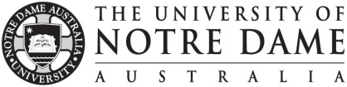
Application Coversheet
Vice Chancellor’s Awards - Promoting Excellence in Learning and Teaching (PELT)
AWARD TYPE: Teaching Excellence

- Name of Applicant/s (add extra rows for teams up to 10 staff)

1.
2.
3.
4.
5.

- Nomination Category (choose one)

- Undergraduate teaching
- Postgraduate teaching
- Early career (no more than 5 years of university teaching experience)
- Sessional teaching

- Application Checklist
- Cover sheet
- Written statement (claims against assessment criteria)
- CV
- Team statement (for team nominations only)
- Two signed letters of reference (one page each)
- Supporting evidence (10 pages and/or website)
- Single pdf document with all documents in order listed above

PLEASE SCAN & RETURN ELECTRONICALLY TO LTO (lto@nd.edu.au) BY NO LATER THAN 6 February 2023

